Research articles regarding the end result and final outcome of any project that involves the medium of wood, from the simple wood pallet, to the tall ships of the 19th century are welcome in this broad category. In other words, if wood is used in the product, or project, it can be researched and written about and entered into this category.
this namespace doesn't exist: works

Images
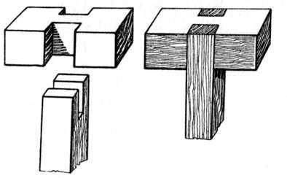Array
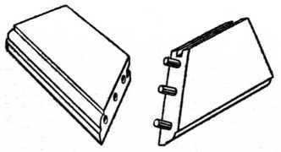Array

